

## Topic: Resetting Your Profile

Are there times when you are unable to access documents in theSource and the system ‘clocks’ after performing a search? First, try logging out of theSource, closing all browsers and then clearing your computer/browser cache. If the issue persists, try resetting your profile!

To reset your profile in theSource, navigate to the Profile icon. Under the Manage tab, select the ‘pencil’ icon to access the Profile.

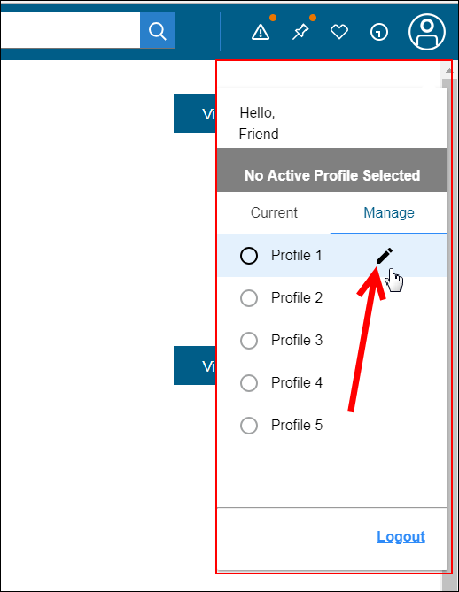

Next, locate the **Reset** button at the bottom of the window and select it to reset your profile.

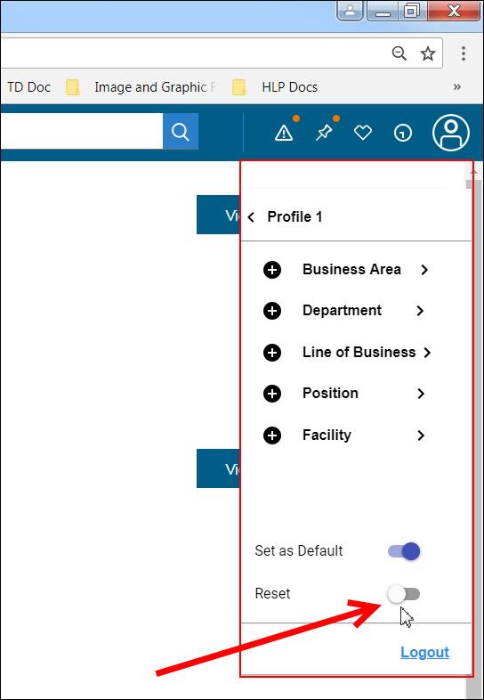

If you have multiple profiles, you will need to perform this process for each profile to reset each.

For assistance personalizing your profile settings on theSource, review [theSource - Profile Settings Reference Guide (Personal Settings)](https://thesource.cvshealth.com/nuxeo/thesource/#!/view?docid=d2e37c4f-7320-473f-95cb-cf06e42e8104).

 Your next challenge on the quest to becoming a Certified theSource Wizard is to try resetting your profile when encountering ‘clocking’ issues in theSource after clearing computer/browser cache.

Additional resources:

* Become a Certified theSource Wizard: Index

Not to Be Reproduced or Disclosed to Others without Prior Written Approval

**ELECTRONIC DATA = OFFICIAL VERSION / PAPER COPY = INFORMATIONAL ONLY**